How to Set Up Flex Builder 3 Environments for Flex Controls

Open Flex Builder 3. Select File → Import → Other.
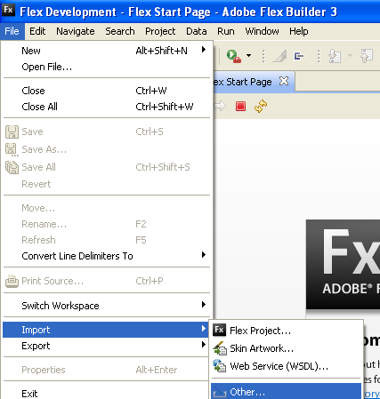

Select General → Existing Projects into Workspace, click Next.
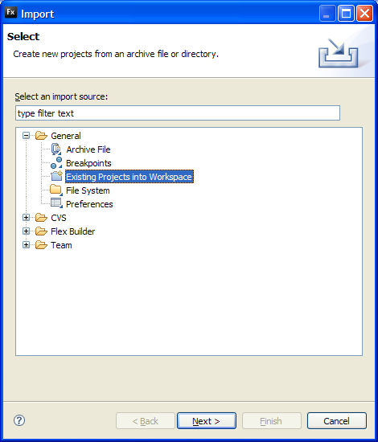

Click Select Root Directory.

Select the C:\Projects\WebCentral\19.1_Production\WebCentral\schema\ab-core\controls-src\ folder.

The project Controls should be automatically selected.

Click Finish.

You are ready to go.

How to Create a Custom Chart Control using Flex Builder 3

In order to write your custom control, you will need to write two main files: your_custom_control.mxml and your_custom_control.as.

You can either extends archibus existing controls or create your own from scratch.
- All your *.mxml files should be in the controls-src\src folder.
- All actionsscript files *.as should be in controls-src\src\chart folder, or in another folder at the same level.

Once you make the changes, you can go to Project→ Build Working Set to build the *.swf files. Or you can select Project → Build Automatically, and Flex Builder will recompile the swf files each time you save an MXML or Action Script file.

All .swf files are compiled into the controls-src\bin-debug folder.

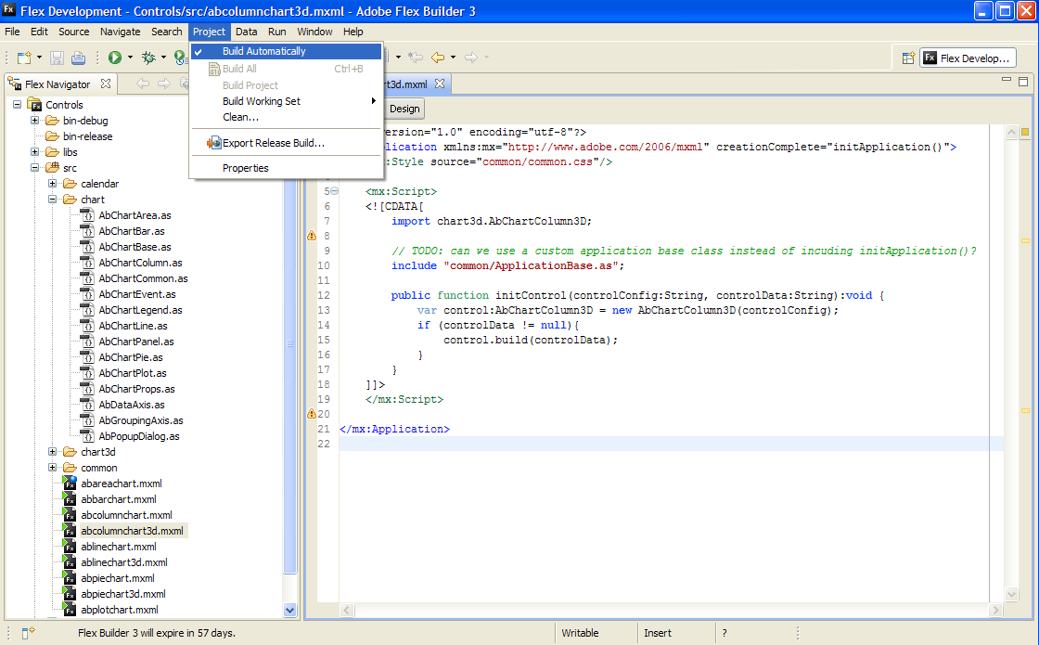

How to Debug a Custom Chart Control using Flex Builder 3

Currently, Flex builder does not have the ability to debug the Action Script files embedded into Web Central views.

Here is how you can test your program:

- Copy your compiled *.swf file from the folder it is compiled to:
schema\ab-core\controls-src\bin-debug
into the chart control folder:
schema\ab-core\controls\chart\

- Start Web Central and load the AXVW view that uses the control, to test if the swf file loads successfully.

- You can debug Java Script code as usual, with Firebug or IE8 Develop Tools.

- You cannot debug Action Script code, but you can output debugging messages from it using the trace() method.

